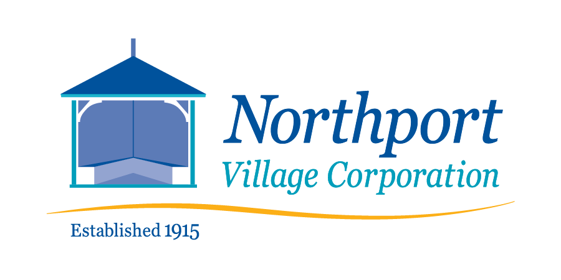
July 10, 2022 – 8:00 a.m.
Meeting of the Northport Village Corporation Board of Overseers
This is a hybrid meeting – in person* in the Community Room of Community Hall, 813 Shore Road, Northport, ME and virtually at:

https://us02web.zoom.us/j/81153548552?pwd=RU8rd1UxUWlUUEYyRklHWFdiektlQT09
*Due to the size of the meeting room and quality of air circulation, masks will be required for the in-person meeting.
Meeting Agenda
- Call to order
- Agenda review
- Comments by members of the public
- Approval of June 12, 2022 minutes
- Village Agent Report
- Treasurer’s Report
  - Approval of Overseers Proposed 2023 Budget and Public Notice of the Annual Meeting
- Committee Reports (as needed)
  - Finance
  - Governance
    - Approval of the proposed By-Law amendments for presentation for approval at the Annual Meeting
  - Tree Warden and Tree Committee
  - Utilities
  - Infrastructure
  - Safety
  - Waterfront Communications
  - Personnel
- Ad Hoc Playground Committee
- Ad Hoc Community Hall Fees/Use Committee
- Technology Officer Report
- President’s Report
- Town Liaison Report
- Other issues or reports
- Comments by members of the public
- Adjourn.

