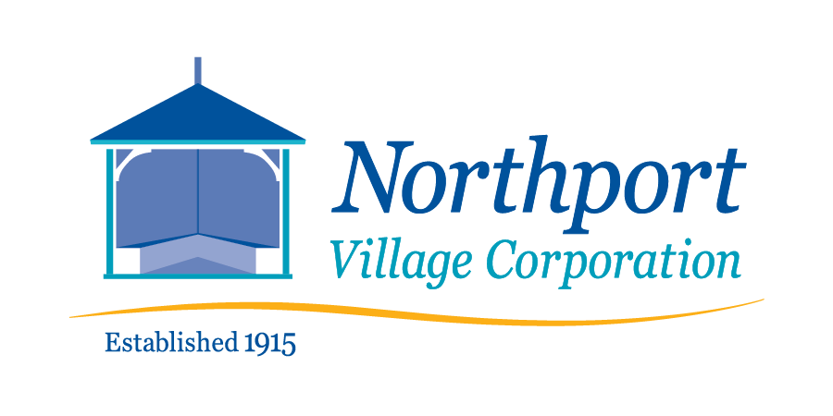

June 11, 2022 – 9:00 a.m.

Northport Village Corporation Board of Overseers

Budget Workshop

This is a hybrid meeting – in person* in the Community Room of Community Hall, 813 Shore Road, Northport, ME and virtually at:
https://us02web.zoom.us/j/87257203302?pwd=VTEvMUVkRXRocVhIc1FHSWxYeTBRUT09
*Due to the size of the meeting room and quality of air circulation, masks will be required for the in-person meeting.

Workshop Agenda
- Call to order

- Review and discussion of draft proposed 2023 budget

- Adjourn

