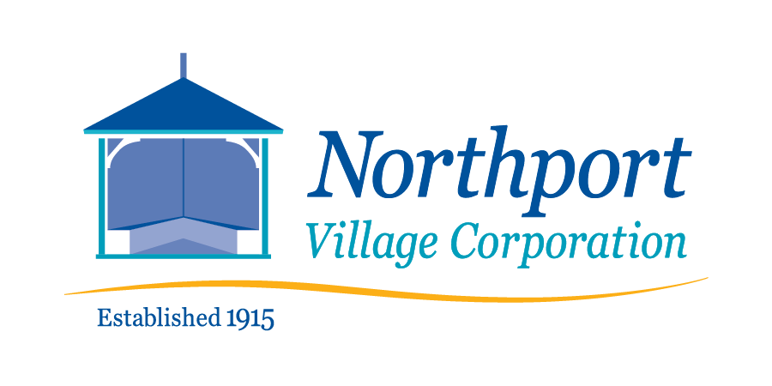
April 10, 2022 – 8:00 a.m.
Meeting of the Northport Village Corporation Board of Overseers
This is a hybrid meeting – in person* in the Community Room of Community Hall, 813 Shore Road, Northport, ME and virtually at:

https://us02web.zoom.us/j/81697005253?pwd=WnBSeFhRMzlOZnh3MjUrLzdkYnBlUT09
*Due to the size of the meeting room and quality of air circulation, masks will be required for the in-person meeting.
Meeting Agenda
- Call to order
- Agenda review
- Comments by members of the public
- Approval of March 27, 2022 minutes (Final draft submitted.)
  - Volunteer to prepare meeting minutes
- Village Agent Report
- Treasurer’s Report
- Committee Reports (as needed)
  - Finance
  - Governance
  - Tree Warden and Tree Committee
    - Recommendation to approve expenditure of $3,726.80 for Emerald Ash Borer treatment by Hawkes Tree Service. (At March meeting, Board approved $3414.00, which was based on Hawkes’ 6/21 estimate. Since 6/21, cost has increased by 10%.)
  - Utilities
  - Infrastructure
    - Recommendation to approve Property Maintenance and Lawn Care Bid Specifications and Contract, Garden Maintenance Bid Specifications and Contract, Curbside Trash & Recycling Pickup Bid Specifications and Contract
  - Safety
  - Waterfront
  - Communications
  - Personnel
- Ad Hoc Parking Ordinance Implementation Committee – Final recommendations regarding signage
- Ad Hoc Playground Committee
- Technology Officer Report
- President’s Report
  - Various facility use requests for Board action
  - Recommendation to authorize the President, on the Overseers’ behalf, to submit a letter of support for Town of Northport’s application for federal funds to build a new Town Office.
- Town Liaison Report
- Other issues or reports
- Comments by meeting attendees
- Adjourn.

