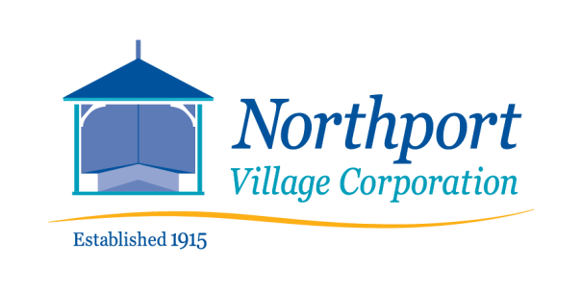
NOTICE OF PUBLIC HEARING:
PROPOSED SEWER CONNECTION MORATORIUM
Bayside Sewer Department
9:00 a.m.
Saturday, March 26, 2022
COMMUNITY HALL
813 Shore Road, Bayside, Northport, ME
The Bayside Utilities Trustees seek public input on a potential moratorium of up to six months for new connections to the Bayside Wastewater Treatment Plant.
You are invited to attend and ask questions and provide input regarding this proposal.
If you cannot attend, your comments are still appreciated. Please email or mail your comments.to Office@nvcmaine.org or to Sewer Department, Northport Village Corporation, 813 Shore Road, Northport, ME 04849
Thank you.
NVC Utilities Trustees

