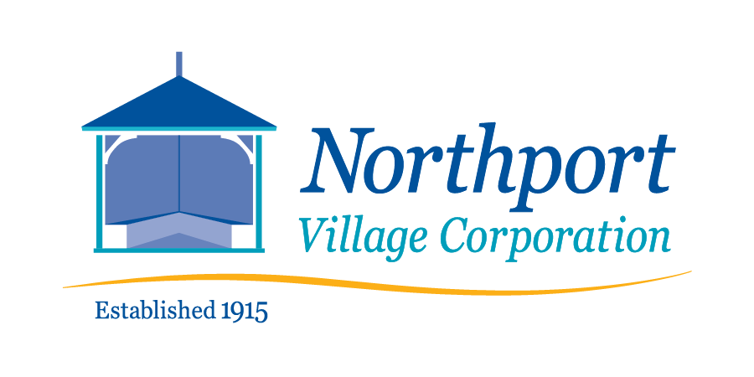
March 27, 2022 – 8:00 a.m.
Meeting of the Northport Village Corporation Board of Overseers
This is a hybrid meeting – in person* in the Community Room of Community Hall, 813 Shore Road, Northport, ME and virtually at:

https://us02web.zoom.us/j/89107128529?pwd=Vm5uK0doNkRYdy9ldUVjSzFHK3dKUT09
*Due to the size of the meeting room and quality of air circulation, masks will be required for the in-person meeting.
Meeting Agenda - Updated
- Call to order
- Agenda review
- Comments by members of the public
- Approval of February 13, 2022 minutes (Final draft submitted.)
- Village Agent Report (Written report submitted.)
  - Recommendation to approve work to reshingle Bayview Park gazebo, as planned in the 2022 budget.
- Treasurer’s Report (Written report submitted.)
  - Recommendation to upgrade QuickBooks subscription.
- Committee Reports, as needed
  - Finance
    - Recommendation to approve warrants policy
  - Governance (Written report submitted.)
  - Tree Warden and Tree Committee (Written report submitted.)
  - Utilities
  - Infrastructure (Written report and proposed agreements submitted.)
    - Easement and indemnification agreement with P. Overgaag and B. Ledyard
    - Bill of sale for playground equipment
  - Safety
  - Waterfront
  - Communications
  - Personnel
- Ad Hoc Playground Committee – recommend final approval of new playground structure
- Technology Officer Report
- President’s Report
  - Various facility use requests for Board action (Written descriptions submitted.)
- Town Liaison Report
- Other issues or reports
- Comments by meeting attendees
- Executive session for personnel matters pursuant to 1 M.R.S.A. § 405(6)(A).
- Adjourn.
- Mini Strategic Planning/Budget Workshop. (Max. 1 hour)
  - Scope of services for upcoming parks maintenance contract and trash disposal contract

