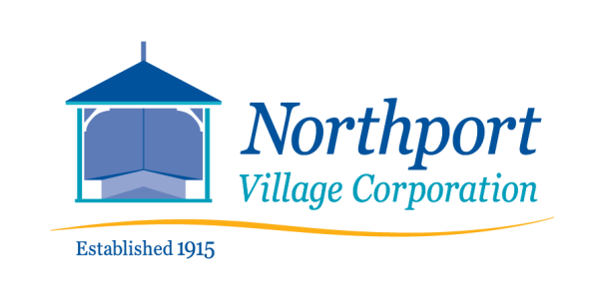
NOTICE OF GOVERNANCE COMMITTEE MEETING:
VIA ZOOM ONLY
The Public is invited to attend via Zoom
9:00 A.M.
Saturday, April 2, 2022
Topic: Governance Committee Meeting
Time: Apr 2, 2022 09:00 AM Eastern Time (US and Canada)
Join Zoom Meeting
https://us02web.zoom.us/j/87363496152?pwd=SW4xZFkxV25jNDkrU05TaXFxbzkrdz09
Meeting ID: 873 6349 6152
Passcode: 516051
AGENDA
- Continue discussion re: review of proposed modifications to Zoning Ordinance
- Continued discussion on policy re: land management
- Review Fireworks Ordinance re: should revisions be recommended to allow Fireworks in off-season with permission of Overseers?
- Continued Discussion re: signage and identification of Village Owned Property and Paths
- By-laws Amendment: to modify quorum requirements for Overseers Meetings and scope of Tree Committee
Thank you.
Judy Metcalf, Chair, NVC Governance Committee

