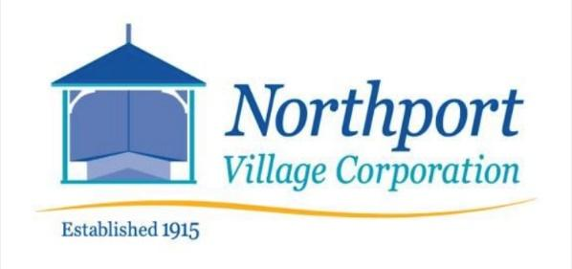

813 Shore Road Phone: (207) 338-0751
Northport, Maine 04849 Email: utilities@nvcmaine.org

The NVC Utilities Committee has the unhappy need to inform sewer users that they will face a sewer rate increase starting with the March 2022 billing.

The Sewer Utility faces large increases in costs related to testing, chemicals for treatment, electrical usage and increased frequency and cost of pumping the septic tanks caused by the shift from seasonal to year-around testing and chemical disinfection as required by Maine EPA. In preparing the 2022 budget, the Utilities Committee anticipates a $12,392 deficit based on current rates. For the 246 sewer users, this amounts to about $51/customer per year to simply reach break-even.

The Utilities Committee has recommended a $75 increase in the Sewer rate, which amounts to $263 per trimesterly billing or a total of $789/year. This increase will allow the utility to cover the proposed deficit and begin the process of rebuilding critical cash reserves

The NVC Overseers have agreed that this rate increase is necessary. This rate increase will be reflected in the March 2022 Utility billing.

We recognize that this imposes economic hardship on many sewer customers, but it is impossible to operate the Wastewater Treatment System with a budget in deficit.

David D. Crofoot, Chairman of the NVC Utilities Committee

