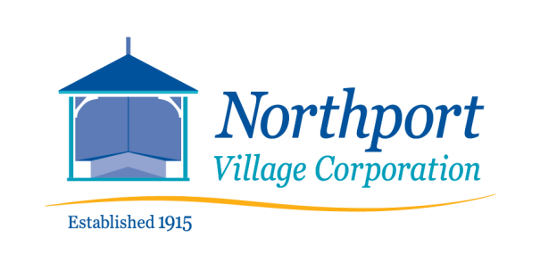
813 Shore Road Phone (207) 338-0751
Northport, Maine 04849

Notice of Finance Committee Meeting
CHANGED TIME
The Finance Committee will be meeting on Tuesday, November 9. 2021 at 5:30 p.m.

The meeting will be held only as a Zoom Meeting. This is a public meeting.

AGENDA

- Status of Audit

- Discussion/Review of Contingency remaining 2021

- 2022 Expense Planning

- Budget Planning: 2023 and 2024

- Financials review

Topic: Finance Committee
Time: Nov 9, 2021 5:30 Eastern Time (US and Canada)

Join Zoom Meeting
https://us02web.zoom.us/j/83364417329?pwd=ODVGeFB0TWp0ZkFZL0xRd2hBblgzdz09

Meeting ID: 833 6441 7329
Passcode: 316193
)
Meeting ID: 833 6441 7329
Passcode: 316193

